

**Project Design Phase-II Technology Stack (Architecture & Stack)**

|  |  |
| --- | --- |
| Date | 14 October 2022 |
| Team ID | PNT2022TMID07316 |
| Project Name | Personal Expense Tracker Application |
| Maximum Marks | 4 Marks |

**Technical Architecture:**

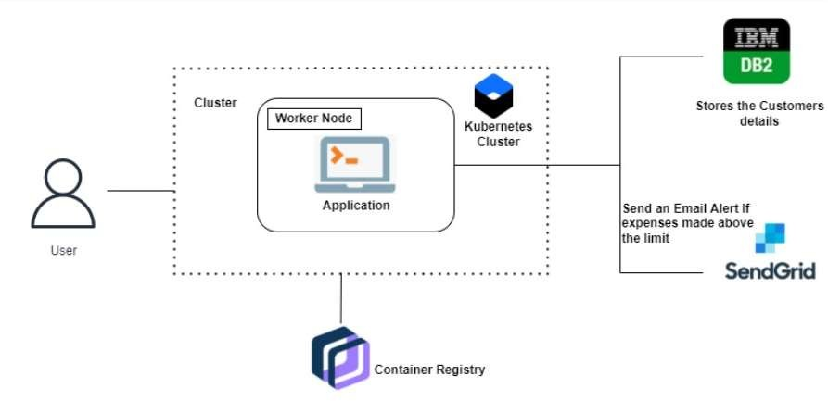



**Table 1: Components & Technologies:**

|  |  |  |  |
| --- | --- | --- | --- |
| **S.No** | **Component** | **Description** | **Technology** |
| 1. | User Interface | The user can interact with the application with the use of a  Chatbot | HTML,CSS,  JavaScript / Angular Js  / React Js etc. |
| 2. | Application Logic-1 | The application contains the sign- in/sign up where the user will log  in to the main dashboard | Java / Python |
| 3. | Application Logic-2 | The dashboard contains the fields like Add income, Add Expenses,  Save Money | IBM Watson STT service |
| 4. | Application Logic-3 | The user will get the expense report in the graph form and also get alerts if the expense limit  exceeds | IBM Watson Assistant |
| 5. | Database | The Income and Expense data are  stored in the MySQL database | MySQL, NoSQL, etc. |
| 6. | Cloud Database | With the use of Database Service on the Cloud, the User data are  stored in a well secure Manner | IBM DB2, IBM  Cloudant etc. |
| 7. | File Storage | IBM Block Storage is used to store the Financial data of the use | IBM Block Storage or Other Storage Service  or Local Filesystem |



**Table 2: Application Characteristics:**

|  |  |  |  |
| --- | --- | --- | --- |
| **S.No** | **Characteristics** | **Description** | **Technology** |
| 1. | Open-Source  Frameworks | Flask Framework in Python is used  to implement this Application | Python-Flask |
| 2. | Security Implementations | This Application Provides high security to the user’s Financial data. It can be done by using the  Container Registry in the IBM cloud | Container Registry, Kubernetes Cluster. |
| 3. | Scalable Architecture | Expense Tracker is a lifetime access supplication. Its demand will increase when the user’s income is  high | Container Registry, Kubernetes Cluster. |
| 4. | Availability | This application will be available to  the user at any part of the time | Container Registry,  Kubernetes Cluster. |
| 5. | Performance | The performance will be high because there will be no network  traffics in the application | Kubernetes Cluster. |

**References:** https://ieeexplore.ieee.org/abstract/document/6759219/citations#citations (PDF) EXPENDITURE MANAGEMENT SYSTEM (researchgate.net) https://ijarsct.co.in/Paper391.pdf